I : Function Order of Growth (20 points)

1. (5 points) Given the following list of 3 functions:

3 (n² ) 25 + ( 8 n ) (n lg n) - 6

Circle the one ordering below in which the 3 functions appear in increasing asymptotic growth order. That is, find the ordering f₁, f₂, f₃, such that f₁= O(f₂) and f₂= O(f₃).

(a) 3 (n² ) 25 + ( 8 n ) (n lg n) - 6

(b) 25 + ( 8 n ) (n lg n) - 6 3 (n² )

(c) (n lg n) - 6 3 (n² ) 25 + ( 8 n )

2. (5 points) Given the following list of 3 functions:

(1/6)n! (2 ^{lg n}) + 5 9 (lg( lg n))

Circle the one ordering below in which the 3 functions appear in increasing asymptotic growth order. That is, find the ordering f₁, f₂, f₃, such that f₁= O(f₂) and f₂= O(f₃).

(a) (1/6)n! (2 ^{lg n}) + 5 9 (lg( lg n))

(b) (2 ^{lg n}) + 5 9 (lg( lg n)) (1/6)n!

(c) 9 (lg( lg n)) (2 ^{lg n}) + 5 (1/6)n!

For problems 3 and 4, assume that:

f₁= Ω(n lgn) f₂= Ο( n²) f₃= Θ(n) f₄= Ω(1)

For each statement: Circle TRUE if the statement is true.
Circle FALSE if the statement is false.
Circle only one choice.

3. (5 points) f₁= Ω( f₃) TRUE FALSE

4. (5 points) f₃= Ο( f₂) TRUE FALSE

II: Solving a Recurrence (10 points)

In each of the 3 problems below, solve the recurrence by finding a closed-form function f(n) that represents a tight bound on the asymptotic running time of T(n).
That is, find f(n) such that T(n) = Θ (f(n)).
1. (5 points) Solve the recurrence : T(n) = T(n/4) + n/2

[You may assume that T(1) = 1 and that n is a power of 2.]

Circle the one answer that gives a correct closed-form solution for T(n)

(a) Θ(n) (b) Θ(n²) (c) Θ(n lg n)

2. (5 points) Solve the recurrence : T(n) = n T( n ) + n
k
[You may assume that T(2) = 1 and that n is of the form 2 ² .]

Circle the one answer that gives a correct closed-form solution for T(n)

(a) Θ(n² lg n) (b) Θ(n lg² n) (c) Θ(n lg(lg n))

III: PseudoCode Analysis (30 points)

Here you’ll use the pseudocode below for two functions Mystery1 and Mystery3.
Mystery1 has three arguments: A : an array of integers; p, r : indices into A

Mystery1(A, p, r)
if p is equal to r
then return 0
q (p+r)/2
g1 Mystery1(A, p, q)
print "Mystery1 result1= ", g1
print contents of A[p]..A[q]
g2 Mystery1(A, q+1, r)
print "Mystery1 result2= ", g2
print contents of A[q+1]..A[r]
g3 Mystery3(A, p, q, r)
print "Mystery3 result= ", g3
print contents of A[p]..A[r]
return g3

Mystery3(A, p, q, r)
initialize integer array B to be empty
bb p
pp p
qq q+1
while pp <= q and qq <= r
do if A[pp] <= A[qq]
then B[bb] A[pp]
pp pp + 1
bb bb + 1
else B[bb] A[qq]
qq qq + 1
bb bb + 1
while qq <= r
do B[bb] A[qq]
qq qq + 1
bb bb + 1
while pp <= q
do B[bb] A[pp]
pp pp + 1
bb bb + 1
a 0
for i p to r
do A[i] B[i]
if i>p
then d |A[i] - A[i-1]|
if d > a
then a d
return a

(a) (10 points) For A = <5,2,16,9,25>, what output is generated by the call Mystery1(A, 1, 5)?

(b) (5 points) Describe in one or two sentences the mathematical meaning of the result of a call Mystery1(A, 1, length[A]) on an arbitrary integer array A.

(c) (10 points) Find a function f(n) that can be used to describe a tight bound on the worst-case asymptotic running time T(n) of Mystery1, where n is the number of elements in array A.
That is, find f(n) such that T(n) = Θ (f(n)).

(You may ignore floors and ceilings in your analysis.)

(d) (5 points) Does the time bound from (c) also describe the best-case and average-case asymptotic running time T(n) of Mystery1? Briefly explain.

IV: Patriotic Trees (40 points)

This problem is based on the definition of a PatrioticTree in the Final Exam Handout (see attachment).

1. (10 points) Consider a PatrioticTree TreeNode t and the two TreeNodes t.left and t.right representing its two children. How many different colorings of the 3 TreeNodes t, t.left and t.right are possible? (circle the one correct answer below)

27 13 23 9 17

2. (5 points) An algorithm MAX_R_COLORING accepts as input a list of initialized TreeNodes representing leaves of a PatrioticTree (initialization provides weight and color for each leaf). Assume that the sum of the RedWeights of the leaves exceeds the sum of the BlueWeights of the leaves. Assume also that MAX_R_COLORING always returns a PatrioticTree (built from the leaves up) in which the number of R-colored internal nodes is maximized. Then the number of R-colored internal nodes in the tree built by MAX_R_COLORING is always: (circle the one correct answer below)

2 f 2f - 1 f + 1 f - 1

3. (25 points) Given a collection of f leaf nodes, develop the algorithm MAX_R_COLORING as described in Problem 2.
In addition to all assumptions listed in the statement of Problem 2, you may assume that:
- There are w white leaves and they are stored in an array W of TreeNodes
- There are r red leaves and they are stored in an array R of TreeNodes
- There are b blue leaves and they are stored in an array B of TreeNodes

a) (15 points) Provide pseudo-code for the algorithm MAX_R_COLORING

b) (5 points) Justify the correctness of the algorithm

c) (5 points) Establish an upper bound on the algorithm’s worst-case running time in terms of the total number of nodes n.

FINAL EXAM HANDOUT

40% of the points on the Final Exam will be based on the representation described in this handout.

We define a new type of tree as follows:
A PatrioticTree is a binary tree of n nodes in which:
- Every internal node has both a left and a right child.
- Each node is labeled with a single color (RED, WHITE or BLUE, which we abbreviate as R, W, or B).
- Each node has a weight. The weight is a pair of integer values and is of the form <r,b>. The first integer value in the pair is the Red Weight of the node = Red Weight of the node’s left child + Red Weight of the node’s right child. The second integer value in the pair is the Blue Weight of the node = Blue Weight of the node’s left child + Blue Weight of the node’s right child. The color of a node is determined as follows:
- R if its Red Weight exceeds its Blue Weight
- B if its Blue Weight exceeds its Red Weight
- W if its Blue Weight equals its Red Weight
- The weight of each W leaf is <0,0>.
- The weight of each R leaf is of the form <r,0>.
- The weight of each B leaf is of the form <0,b>.
W
<0,0>

R
<4,0>

B
<0,5>

R
<3,0>

B
<0,3>

W
<0,0>

W
<3,3>

B
<0,6>

R
<2,0>

B
<2,6>

B
<2,6>

B
<7,8>

B
<0,5>

B
<9,14>

B
<3,8>

EXAMPLE of a PatrioticTree:

In this example:

- there are 8 leaf nodes
- there are 7 internal nodes
(including the root)
- the total number of
nodes is 15
FINAL EXAM HANDOUT
(continued)

For algorithmic purposes, we represent a PatrioticTree as follows:

A TreeNode represents a node of a PatrioticTree. It contains the attributes:
- color: a character representing its color: “R”, “B” or “W”
- r: an integer representing its Red Weight
color
r
parent
left
b
right
- b: an integer representing its Blue Weight
- parent: a pointer to the parent of this node
- left: a pointer to the left subtree of this node
- right: a pointer to the right subtree of this node

You can access a node’s attributes using the “.” notation (e.g. for a TreeNode t, t.color gives its color and t.left accesses its left subtree).

1: (20 points) Given the recurrence:

T(n) = T(n/2) + 3T(n/3) + 4T(n/4) + 7n²

(a) (10 points) Show that T(n) = O(n³)

(b) (10 points) Show that T(n) = Ω(n^{3/2})

2: True/False (30 points) Circle TRUE if the statement is true. Circle FALSE if the statement is false. Circle only one choice.

(a) (15 points) If f₁= n 2^{n} , f₂ = 2^{n+1} then f₁= Ο( f₂ )

TRUE FALSE

(b) (15 points) Clustering for dynamically resizable hash tables

Define a dynamically resizable hash table to be one in which, whenever the hash table becomes full, the size of the hash table is doubled, and all entries are removed from the small hash table and inserted into the new, larger hash table.

Consider a hash table H₁ of size m and a hashing function h₁(k) = k mod m. Let H₂ be of size 2m. Suppose that open addressing with linear probing is used for both H₁ and H₂. Let the hashing function for H₂ be h₂(k) = k mod 2m.

If, for the keys k₁, k₂, ..., k_{b} it is the case that
k₁ mod m = k₂ mod m = ... = k_{b} mod m
and when these keys are inserted (in the order given) into H₁ they occupy consecutive slots in H₁, then if only k₁, k₂, ..., k_{b} are inserted into H₂ (in the same order) they also occupy consecutive slots in H₂.

TRUE FALSE

3: (50 points) This is based on the Exam Handout.
distributed on 11/17 (see attachment).

(a) (5 points) Here we examine the amount of storage required for this representation. If each Key Node counts as one unit of storage and each Neighbor Ring Node also counts as one unit, give (and briefly justify) a tight (upper and lower) bound on the worst-case number of storage units needed for this representation as a function of n, the total number of Key Nodes.

(b) (5 points) A neighbor triple is a triple of Key Nodes <k₁, k₂, k₃ > such that each pair within the triple has the neighbor relation. (In the example in the exam handout, the nodes with keys a, b, and c are in a neighbor triple.) In the worst case, how many neighbor triples can there be (as a function of n, the total number of Key Nodes)?

Clarification: We consider all neighbor triples containing k₁, k₂, and k₃ to be the same.

(c) (40 points) Using the neighbor triple definition in (b):
- Given a reference (pointer) to a Key Node k, give pseudo-code to decide if k is part of a neighbor triple. If k is part of a neighbor triple, the pseudo-code should print out “yes” plus the 3 key values of a neighbor triple. (You need not find all triples; you may stop after finding the first one.) If k is not part of any neighbor triple, the pseudo-code should print out “no”.
- Justify the correctness of your algorithm.
- Give (and justify) a tight (upper and lower) bound on your algorithm’s worst-case asymptotic running time as a function of n, the total number of Key Nodes.

Exam Handout

This reinforces material from Chapters 1-12. Date Distributed: Friday, 11/17

The open-book exam on Monday, 11/20 will contain a 50-point question based on the scenario described below.

In this problem, there are two types of list nodes:
1) a Key Node that contains the attributes:
key
info
ring
- key: a key value
neighborCCW
neighborCW
neighbor
keyNode
- info: satellite data
- ring: a pointer to a linked list of Neighbor Ring Nodes
We call this list a Neighbor Ring.
2) a Neighbor Ring Node that contains the attributes:
- keyNode: a pointer to the Key Node for this Neighbor Ring
- neighbor: a pointer to a Neighbor Ring Node for a neighbor of this Key Node’s Neighbor Ring
- neighborCCW: a pointer to the next Neighbor Ring Node in this Key Node’s Neighbor Ring (where next is in the counter-clockwise direction)
- neighborCW: a pointer to the next Neighbor Ring Node in this Key Node’s Neighbor Ring (where next is in the clockwise direction)
You can access a node’s attributes using the “.” notation (e.g. for a Key Node k, k.key gives its key and for a Neighbor Ring Node n, n.neighbor gives its neighbor).
The neighbor relation is symmetric: if a is a neighbor of b, then b is a neighbor of a.
You may assume that there is a total of n Key Nodes.

(See Example on Next Page)

[Note: Representations that use neighbor rings are often useful in graphics and geometric modeling applications.]

Example:
- Nodes with key values a and b are neighbors
- Nodes with key values a and c are neighbors
- Nodes with key values b and c are neighbors
- Nodes with key values c and d are neighbors
neighborCCW
neighborCW
neighbor
keyNode
neighborCCW
neighborCW
neighbor
keyNode
neighborCCW
neighborCW
neighbor
keyNode
neighborCCW
neighborCW
neighbor
keyNode
neighborCCW
neighborCW
neighbor
keyNode
key
info
ring
a
key
info
ring
b
key
info
ring
c
key
info
ring
d
neighborCCW
neighborCW
neighbor
keyNode
neighborCCW
neighborCW
neighbor
keyNode
neighborCCW
neighborCW
neighbor
keyNode
3. (10 points) Minimum Spanning Trees: For the undirected, weighted graph below:
A
B
C
D
E
F
G
2
2
1
1
3
4
4
5
6
6
8
7

Show 2 different Minimum Spanning Trees. Draw each using one of the 2 graph copies below. Thicken an edge to make it part of a spanning tree.

What is the sum of the edge weights for each of your Minimum Spanning Trees?

4. (5 points) For the directed, weighted graph below, find the shortest path that begins at vertex A and ends at vertex F.

A
B
C
D
E
F
G
2
2
1
1
3
4
4
5
6
6
8
7

- (4 points) List the vertices in the order that they appear on that path

- (1 point) What is the sum of the edge weights of that path?

I : Multiple Choice (10 points)

1. (5 points) Function Order of Growth

Given the following list of 3 functions:

(n² lg n) - 6 (n lg³ n) + 12n (5n/6)²

Circle the one ordering below in which the 3 functions appear in increasing asymptotic growth order. That is, find the ordering f₁, f₂, f₃, such that f₁= O(f₂) and f₂= O(f₃).

(a) (n lg³ n) + 12n (5n/6)² (n² lg n) - 6

(b) (5n/6)² (n lg³ n) + 12n (n² lg n) - 6

(c) (5n/6)² (n² lg n) - 6 (n lg³ n) + 12n

2. (5 points) Solve a Recurrence

In the problem below, solve the recurrence by finding a closed-form function f(n) that represents a tight bound on the asymptotic running time of T(n).
That is, find f(n) such that T(n) = Θ (f(n)).
Solve the recurrence: T(n) = 9T(n/3) + (n+2)(n-2)

[You may assume that T(1) = 1 and that n is a power of 3.]

Circle the one answer that gives a correct closed-form solution for T(n)

(a) Θ(n) (b) Θ(n²) (c) Θ(n lg n) (d) Θ(n² lg n)

II: True/False (15 points)

For each problem in this section: Circle TRUE if the statement is true.
Circle FALSE if the statement is false.
Circle only one choice.

1. (5 points) Function Order of Growth: What can you conclude?

Assume that:

f₁(n)= Ο(2^{n}) f₃(n)= Θ(f₂(n)) f ₃(n)= Ω(n) f₄(n)= Ω(n³)
If we also know that f₃(n) = Ω( f₄(n)), then we can always conclude that f₂(n) = Ω( n³).

TRUE FALSE

2. (5 points) Bounds on Alg vs Problem/ Types of input

Given a problem P, suppose that:

- someone designs algorithm A₁ to solve P
- someone designs algorithm A₂ to solve P
- T(A_{i}) represents the asymptotic running time of algorithm A_{i}
- someone constructs a proof that solving an arbitrary instance of P requires at least time in Ω(n).
- the designer of algorithm A₁ claims that algorithm A₁ is in O(2^{n}) for worst-case inputs
- the designer of algorithm A₂ claims that algorithm A₂ is in O(n²) for worst-case inputs

If all these proofs and claims are correct, then we know that

T(A₂) is in Ω(n) and T(A₂) is in Ο(n³)

TRUE FALSE

3. (5 points) The tree shown below on the right can be a DFS tree for some adjacency list representation of the graph shown below on the left.

TRUE FALSE

B
E
C
F
D
A
A
C
B
E
D
F
Tree Edge
Tree Edge
Tree Edge
Tree Edge
Tree Edge
Cross Edge
Back
Edge

1: True/False (20 points = 10 points each)

For each statement: Circle TRUE if the statement is true.
Circle FALSE if the statement is false.
Circle only one choice.

(a) if f₁= Θ(f₂) then f₁= Ο(f₂) and f₂= Ο(f₁) TRUE FALSE

(b) if f₁= Ο (n²) and f₂= Ω(n) and f₃= n lgn TRUE FALSE

then f₃= Ο (f₁) and f₃= Ω(f₂)

and f₃= Ω (n) implies f₃= Ω (f₂)

2: Multiple Choice (30 points)

For each statement: circle the one answer that is true.
M
R
L
M
L
M
R

We define a new type of tree as follows: An i/3-tree is one in which:
- Each node may have children of the following types: left-child, middle-child, or right-child. Each node is labeled with its type as follows: L for left-child, M for middle-child and R for right-child (we consider the root to be a middle child).
- Each node has at most i children (see picture on the right for an example of a 2/3-tree).
A complete i/3-tree is an i/3-tree in which each node has exactly i children (clarification: at all levels except the lowest).
Solution to extra credit:

5 points
(a) The number of different complete 3/3-trees with 13 nodes is:

(i) 27 (ii) 1 (iii) 3 (iv) 18 (v) 9

10 points
(b) The number of different complete 1/3-trees with 3 nodes is:

(i) 27 (ii) 16 (iii) 3 (iv) 18 (v) 9

(c) If we construct a 1/3-tree randomly so that, for each node, the probability that it has a left child is the same as the probability that it has a right child and the same as the probability that it has a middle child, then the expected number of middle children (including the root node) in a complete 1/3-tree with 3 total nodes is:
15 points

(i) 9 (ii) 18/16 (iii) 3 (iv) 15/9 (v) 2

Extra Credit:
20 points
The number of different complete 2/3-trees with 7 nodes is:

(i) 27 (ii) 16 (iii) 3 (iv) 18 (v) 9

Derive a general formula for the number of different complete i/3-trees, where the tree has j levels.
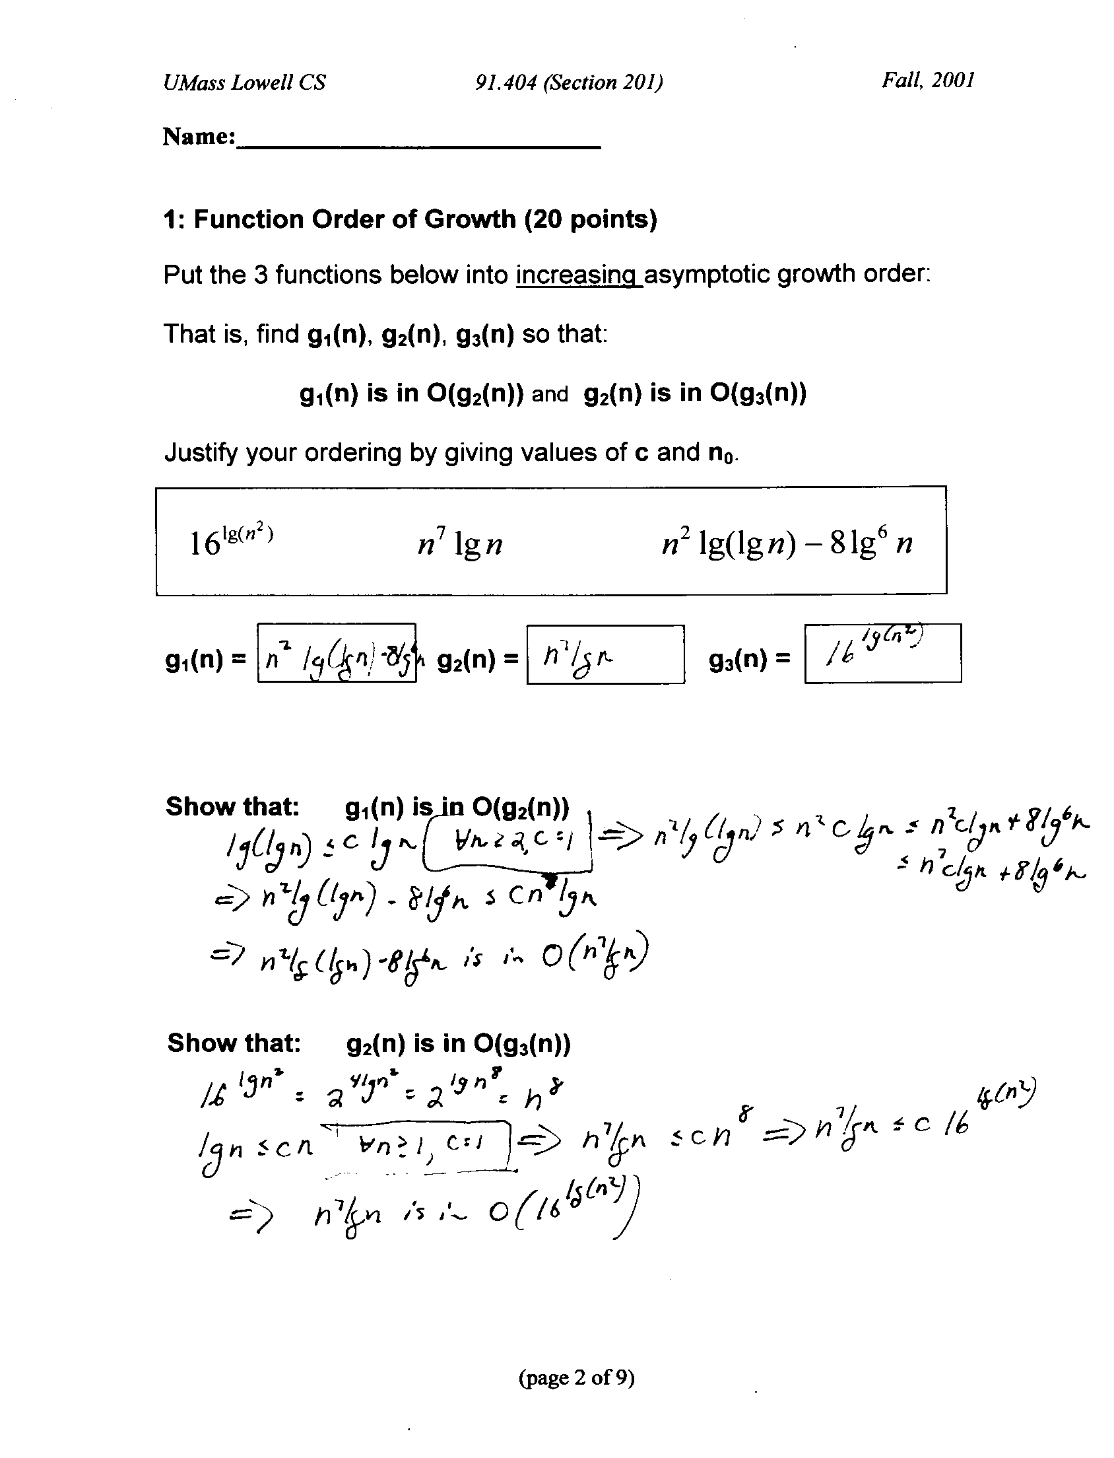
Answer:

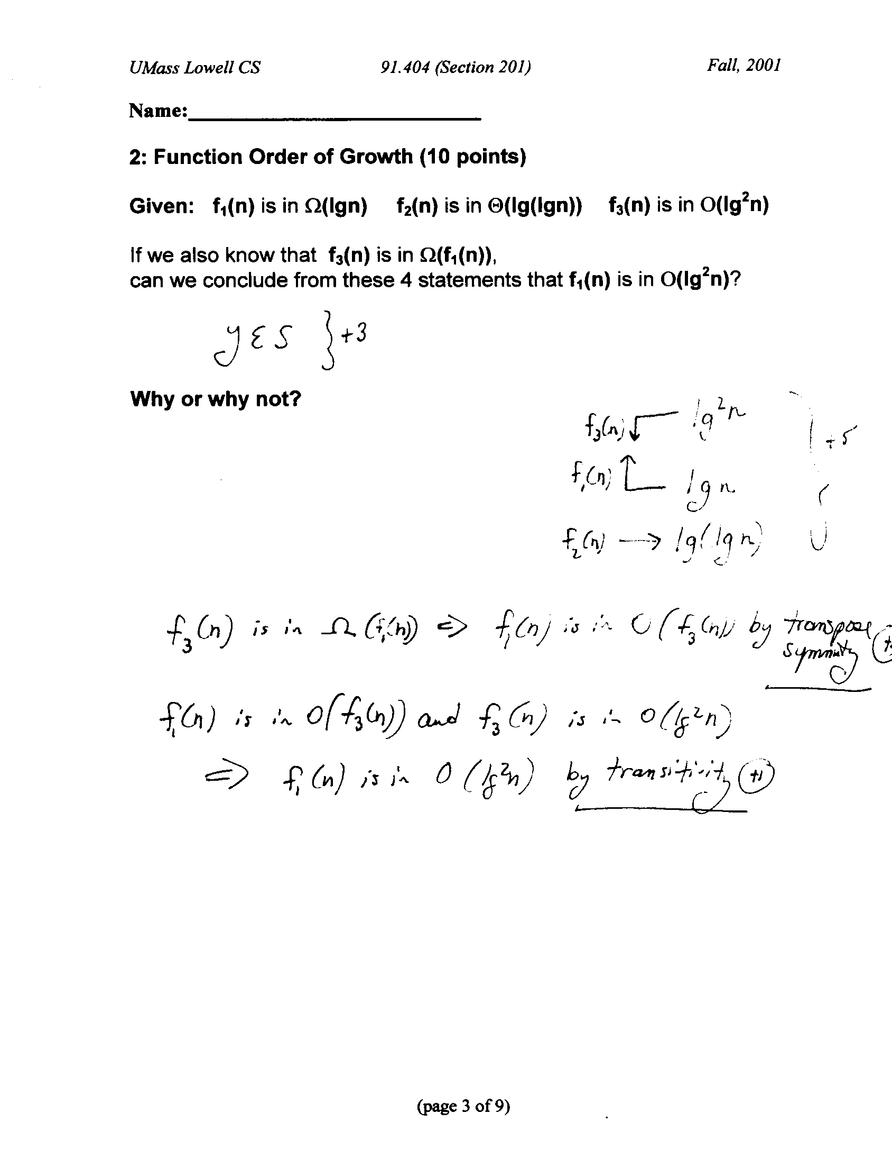
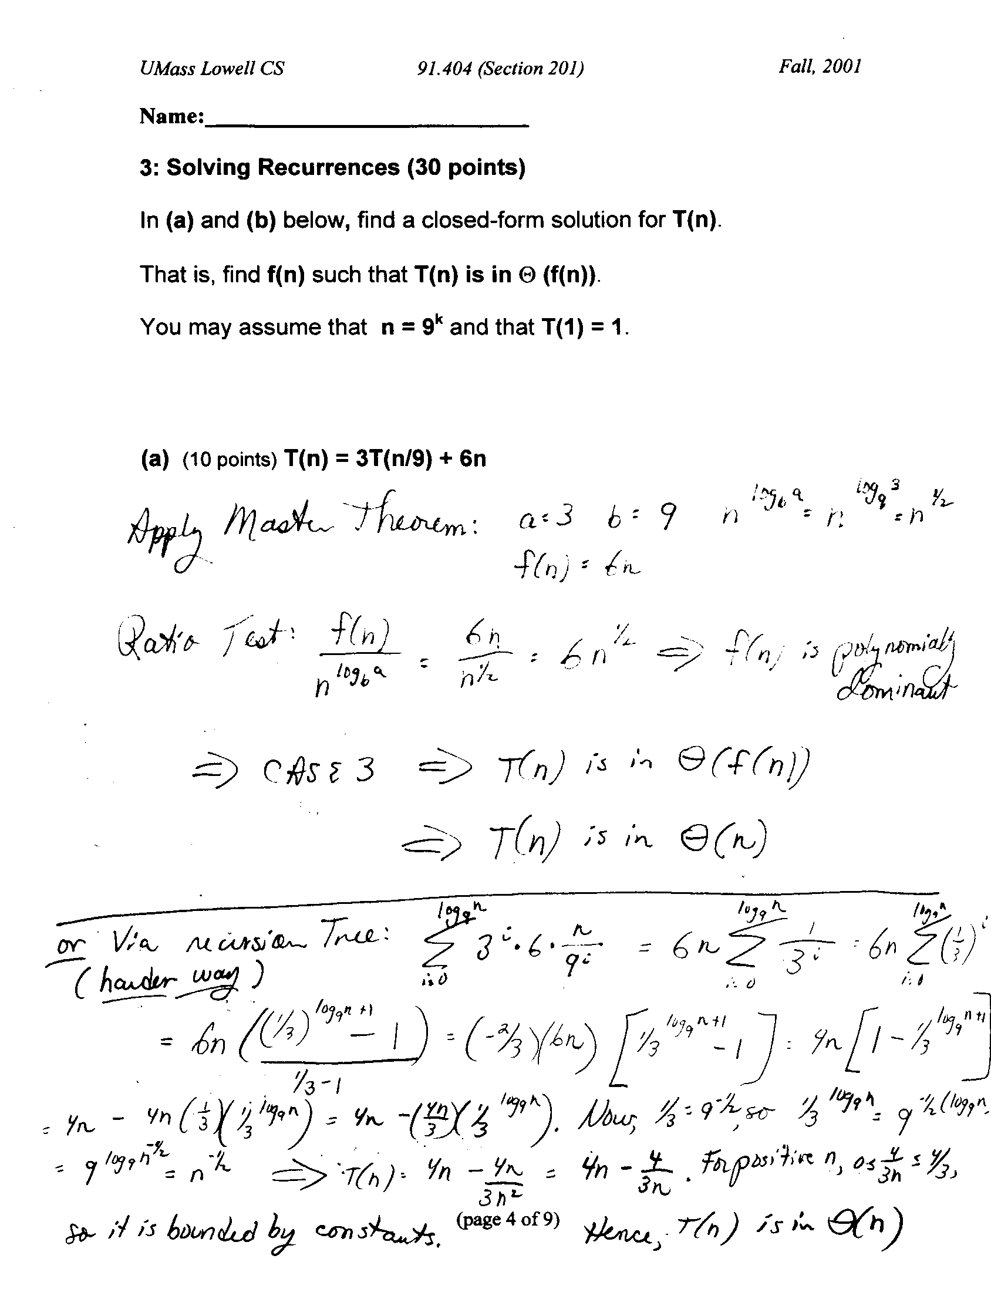
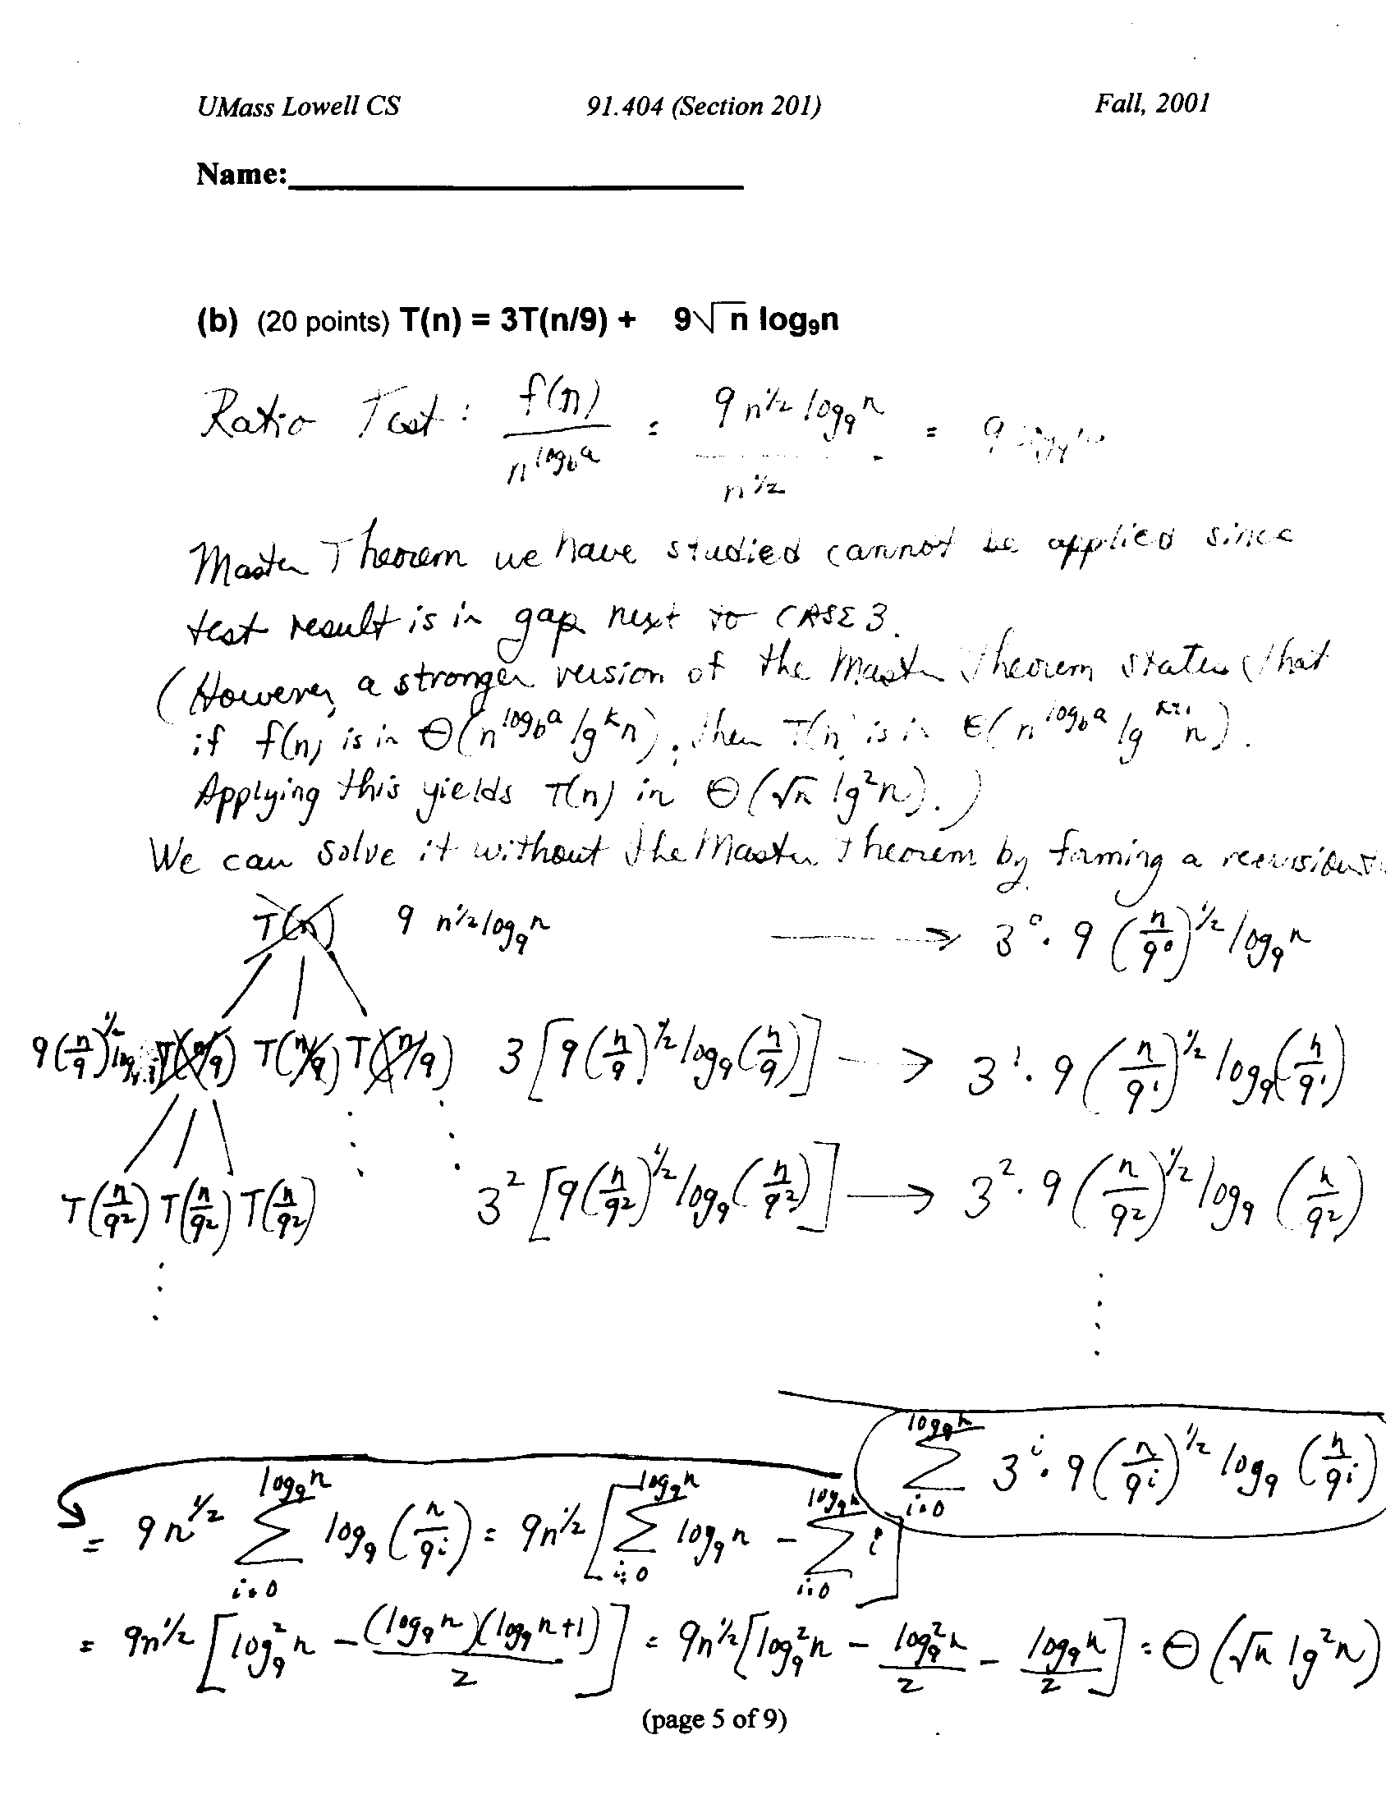

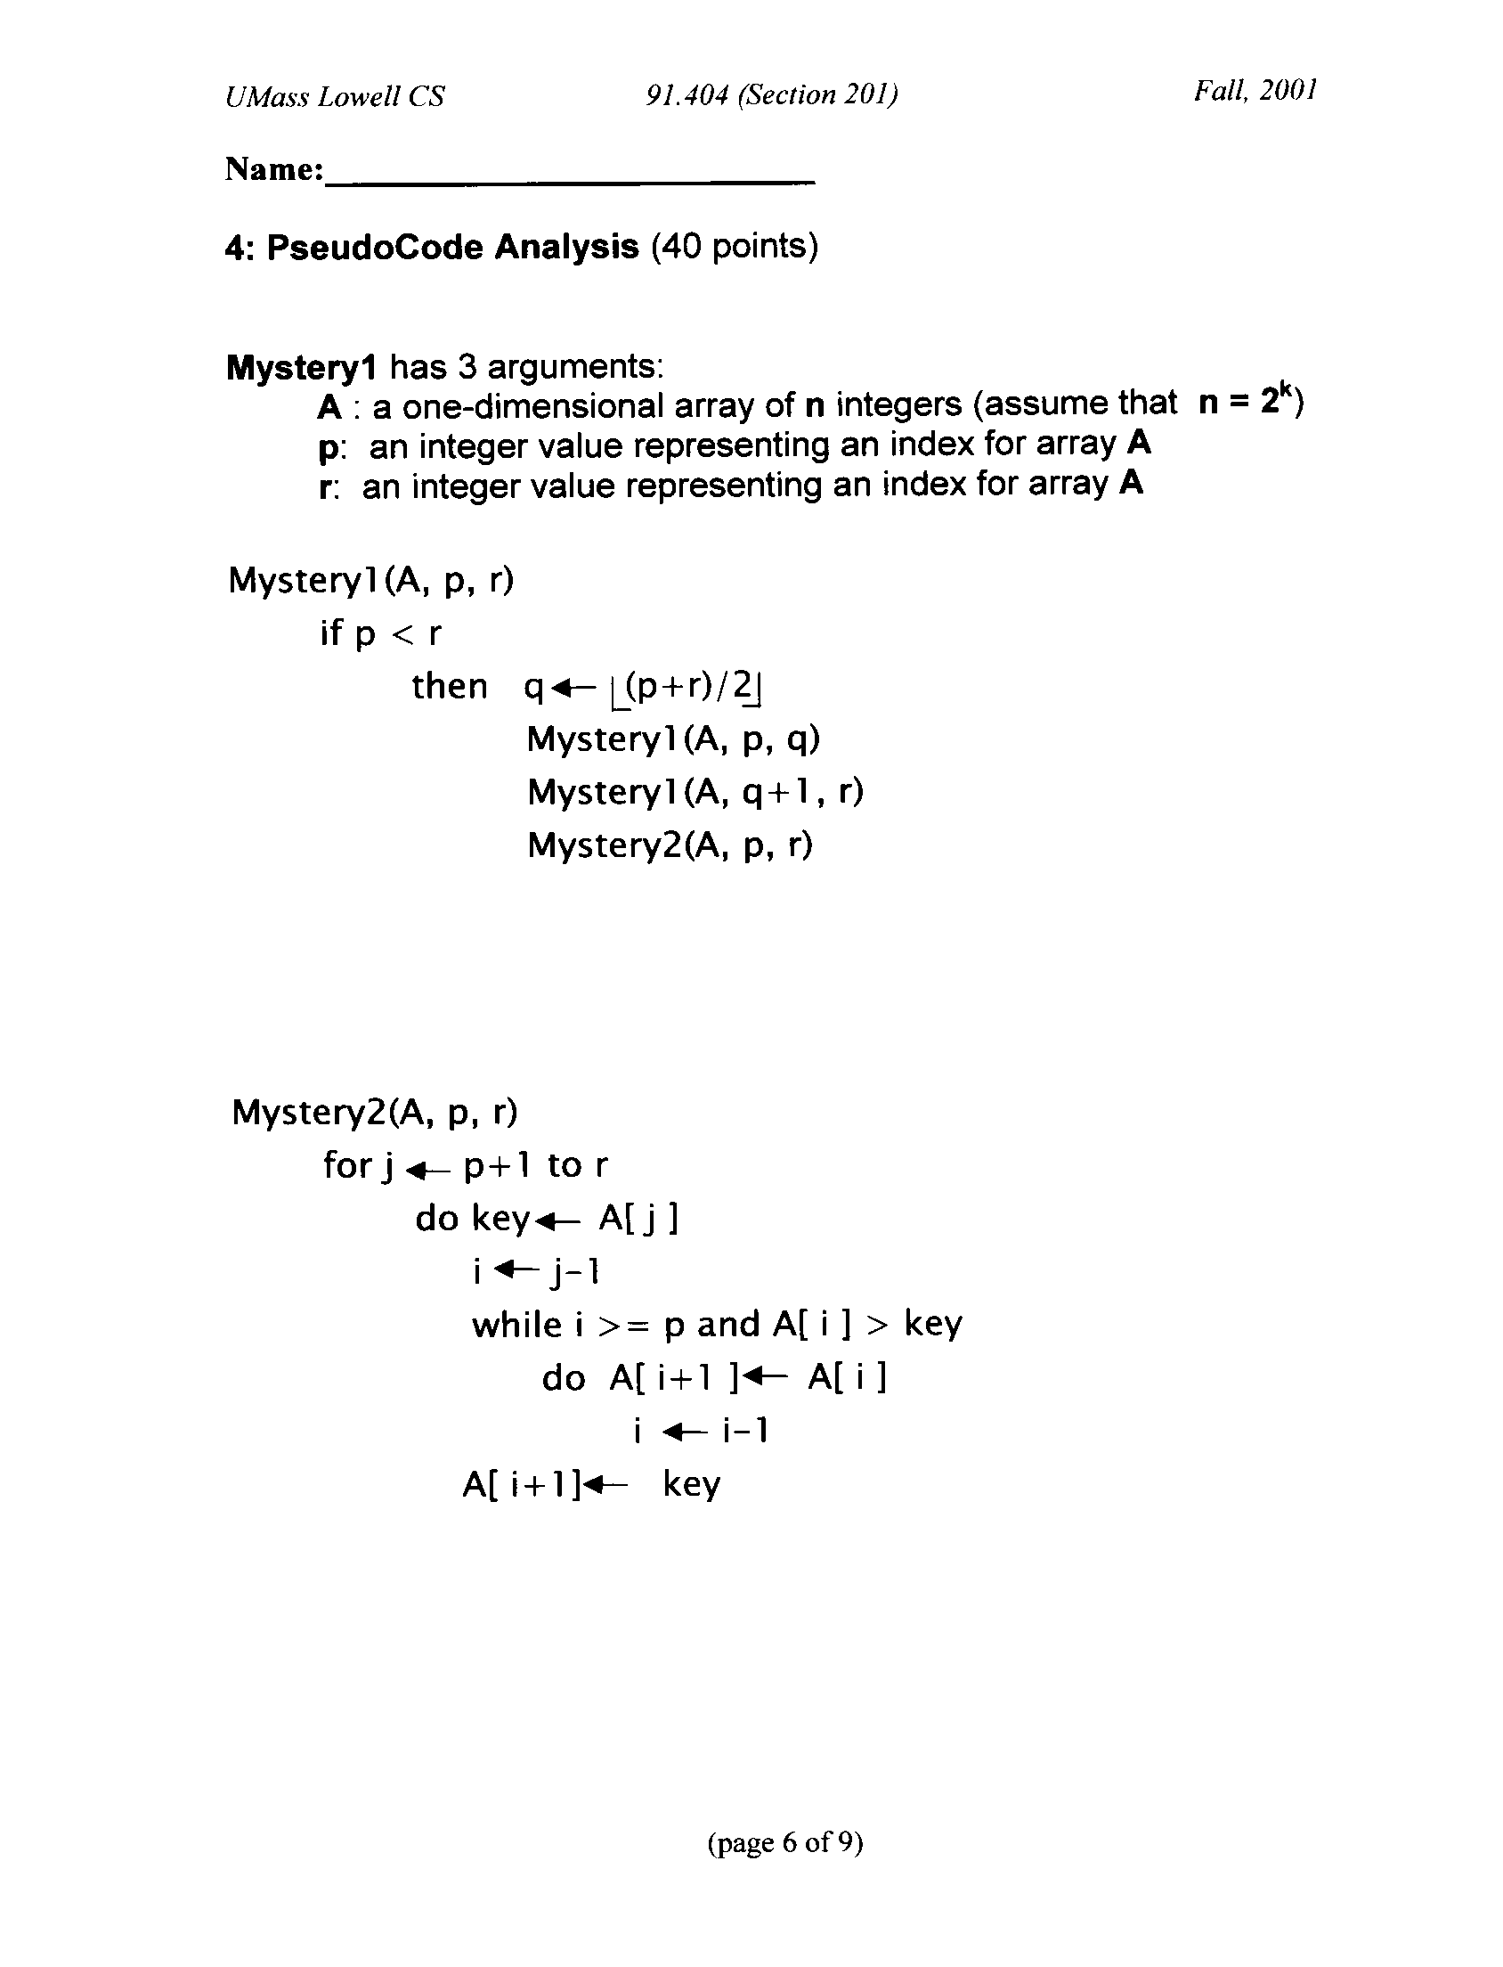
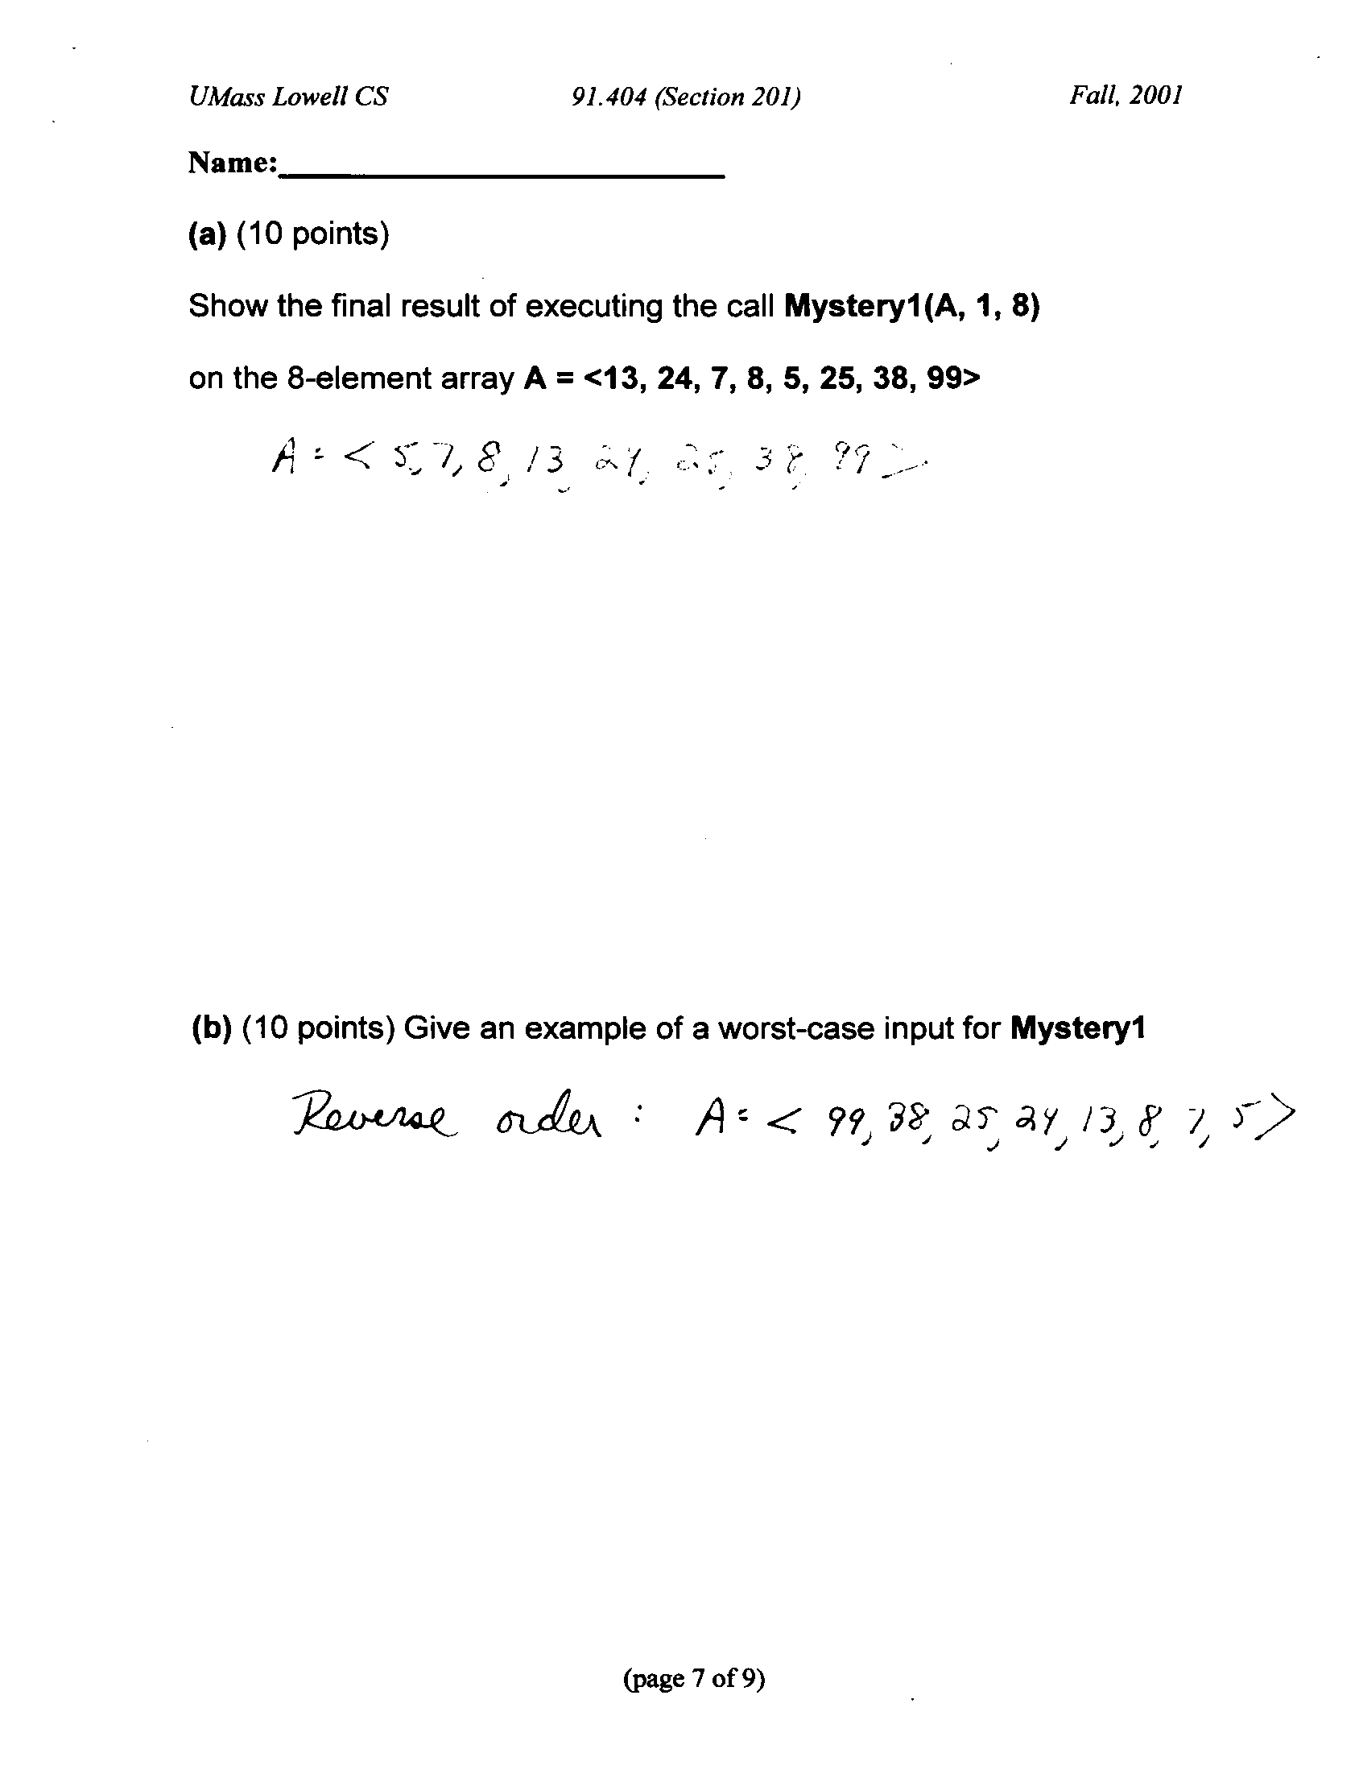
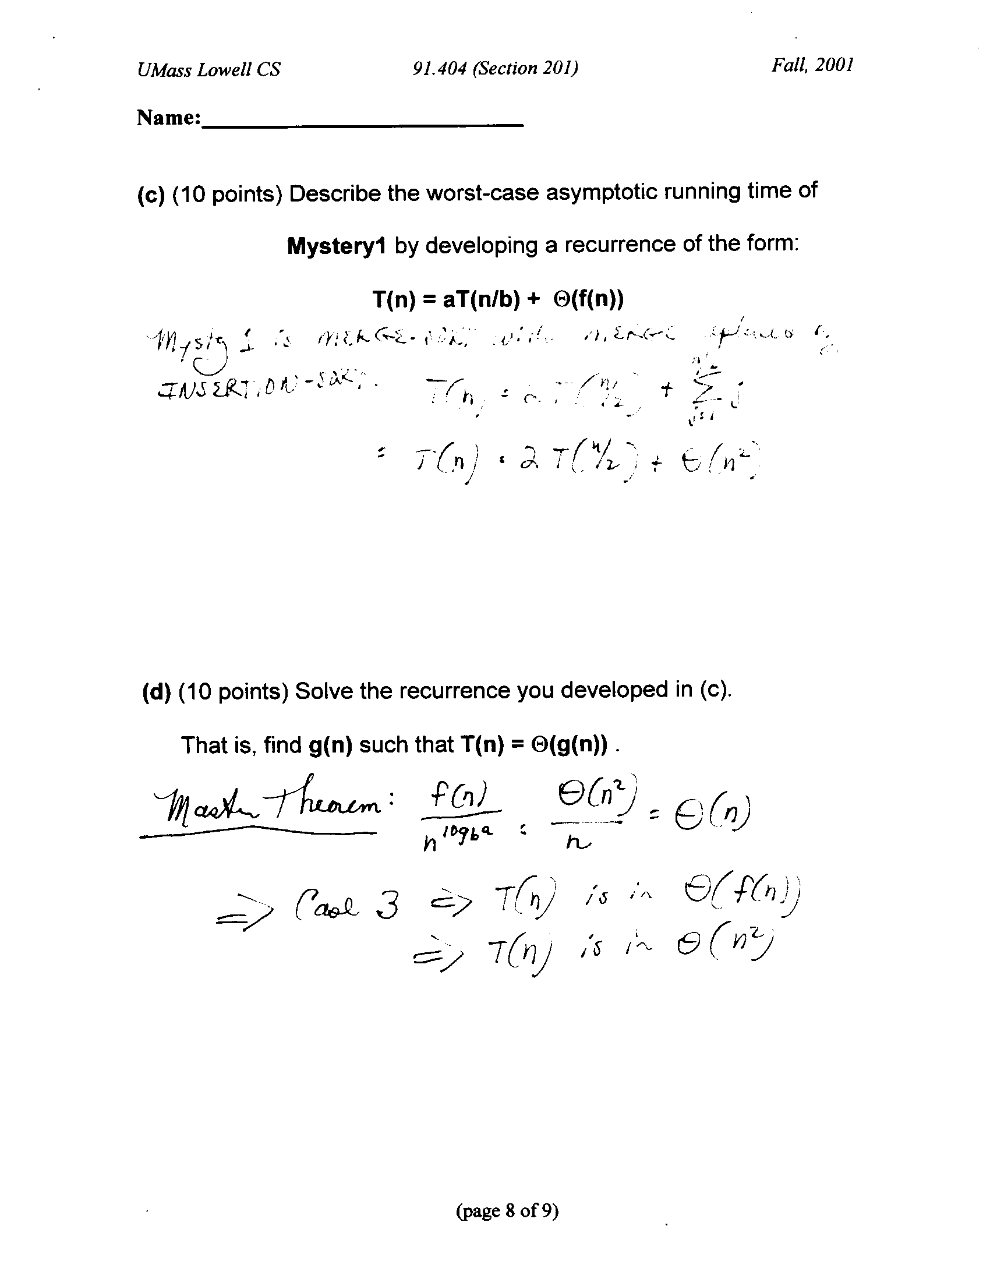
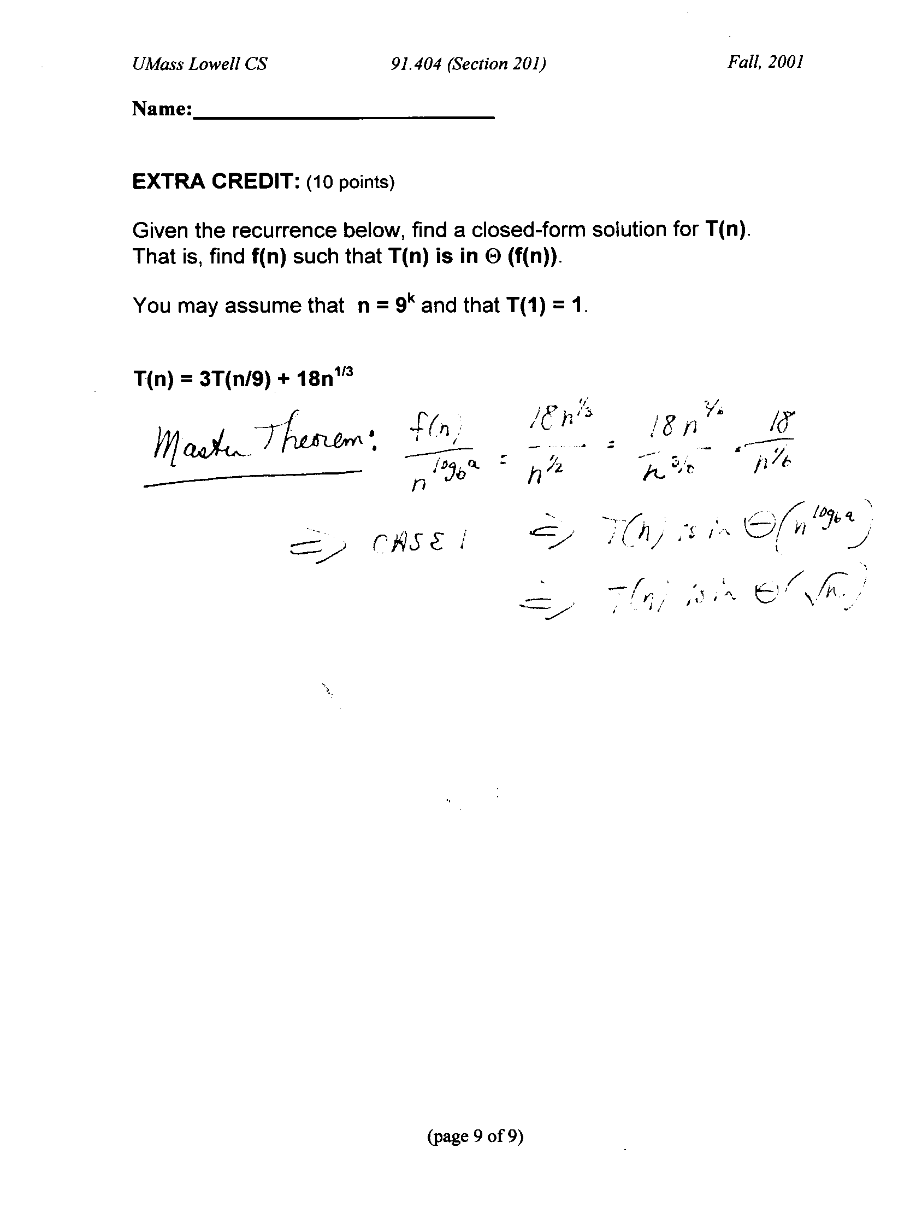
3. (50 points) This question is based on the Exam Handout distributed on 10/27 (see attachment to exam).
Clarifications:
- The delivery schedule S_{i} only needs to contain the messageID, not the entire message.
- Message processing algorithm operates on entire queue to produce Delivery Schedule; no new messages added during this processing.

For a single node v_{i}:

(a) (5 points) Where in the message processing algorithm is sorting required in order to produce S_{i} ? Explain.

(b) (30 points) Assuming that fast asymptotic running time is the most important judgment criterion, what type of sorting algorithm(s) is (are) appropriate for use within the message processing algorithm?
Justify your answer. For each sorting algorithm that you select, your answer should describe the algorithm by writing pseudo-code and stating:
(i) whether it is a comparison-based sort or a non-comparison-based sort
(ii) in more detail what type of sorting algorithm it is. For example, is it a MergeSort? an InsertionSort? a HeapSort? a BucketSort? a RadixSort? A variation on one of these types?
(iii) the worst-case asymptotic running time
(iv) the worst-case size of the delivery list (clarification: this is S_{i})
(v) the amount of extra storage you use (for data structures other than C_{i}, Q_{i}, S_{i})

Note: You need not write out pseudo-code that appears in our textbook; simply cite the page reference. However, if you modify pseudo-code that appears in our textbook, you must write pseudo-code for your modifications. You may assume the existence of a queue data structure that has the following O(1) time operations: enQueue(Q, x), deQueue(Q,x), (clarification: and deQueue(Q)) isEmpty(Q). You may also assume that the operations dynamically allocate storage as needed.

(c) (15 points) Describe how your results for (b) change if we change our assumptions so that a message priority may have any integer value larger than 0.

Exam Handout

This reinforces material from Chapters 1-11. Date Distributed: Friday, 10/27

The open-book exam on Wednesday, 11/1 will contain a 50-point question based on the scenario described below.

Suppose that you are working for a company that designs message processing algorithms for managing message deliveries on a network. For the purposes of the algorithm, the network is modeled as a collection of vertices in an undirected graph G (refer to Chapter 5 if necessary for graph definitions). Each vertex represents a node in the network. If there is a direct network connection between two nodes in the network, then the vertices representing those two nodes have an edge in the graph G. (Note: We assume that two nodes have a direct network connection if and only if a message sent from one node to the other does not need to pass through any additional nodes in the network.) Each node can only send messages to nodes to which it is directly connected.
Each message consists of a header and a body. The header consists of metadata that describes the message: a message ID, its destination list and its delivery priority. A destination is another node in the network to which the message must be sent; we represent as an integer (e.g. 0 for vertex v₀). A destination list is an ordered list of destinations. The message must visit its destinations in the order in which they appear in its destination list: i.e. visit the first, then the second, and, ultimately, the last. The message’s delivery priority is an integer in between 1 and 10, where 10 is the highest priority value. The message ID is a unique integer for each message.
Each node/vertex v_{i} has:
- a message processor P_{i} that can execute algorithms;
- a FIFO message queue Q_{i} containing m_{i} messages;
- a list C_{i} of the nodes to which it is directly connected.
When a message arrives at v_{i}, the first destination in its destination list (which is v_{i}) is removed from the message header. If v_{i} is the final destination (that is, the destination list is now empty), the message is not added to Q_{i}. If the next destination (which is now first in the destination list) is not in C_{i}, the message is not added to Q_{i}. Otherwise, the message is added to Q_{i}.
The message processing algorithm that executes on P_{i} must examine Q_{i} and produce a delivery schedule S_{i}. The schedule S_{i} lists the messages that v_{i} will send. In S_{i}, the messages appear in the order in which they will be sent. This order is determined based on the delivery priority and the order in which the messages appear in the message queue Q_{i}. The order is consistent with the delivery priorities and the arrival order in Q_{i} is used to break ties.
v₁
v₂
v₃
2
C₁
1
C₂
3
2
C₃
Example:
messageID: 6
destinationList: 1
priority: 8
messageID: 5
destinationList: 3
priority: 8
messageID: 4
destinationList: 1
priority: 6
S₁
messageID: 2
messageID: 1
messageID: 2
destinationList: 2
priority: 10
messageID: 1
destinationList: 2, 3
priority: 5
S₂
messageID: 5
messageID: 6
messageID: 4
These will remain the same as algorithm(s) execute
These will change as algorithm(s) execute.
Here we show an example for one time period.
v₁
Q₁
Q₂
v₂
G

messageID: 3
destinationList: 2
priority: 1
Q₃
S₃
messageID: 3
v₃

